1. Create a Pivot table and show what the main export product is?

Scale

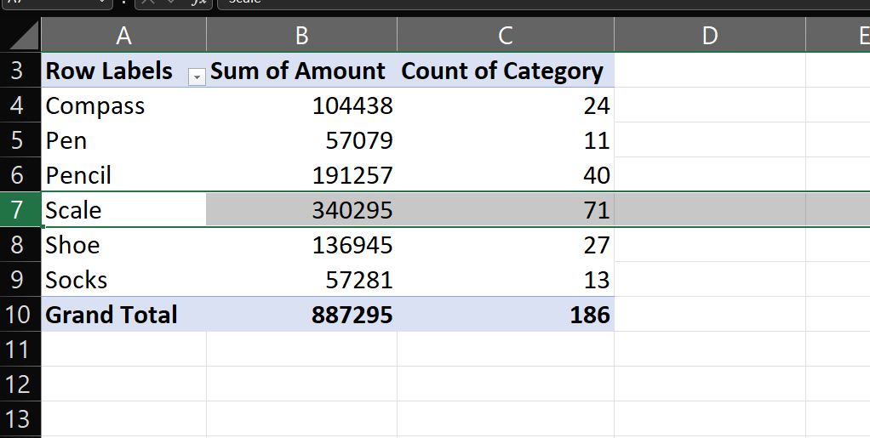

1. Create a bar graph showing the amount spent for each product?

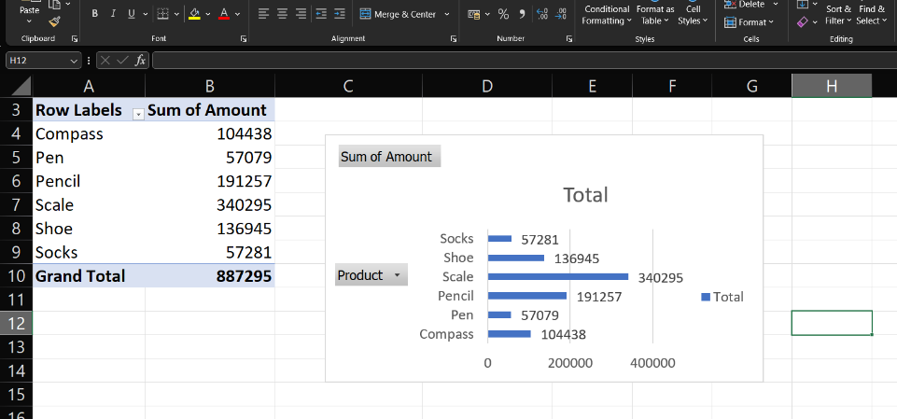

1. Create a Pivot table to show The sales in each city

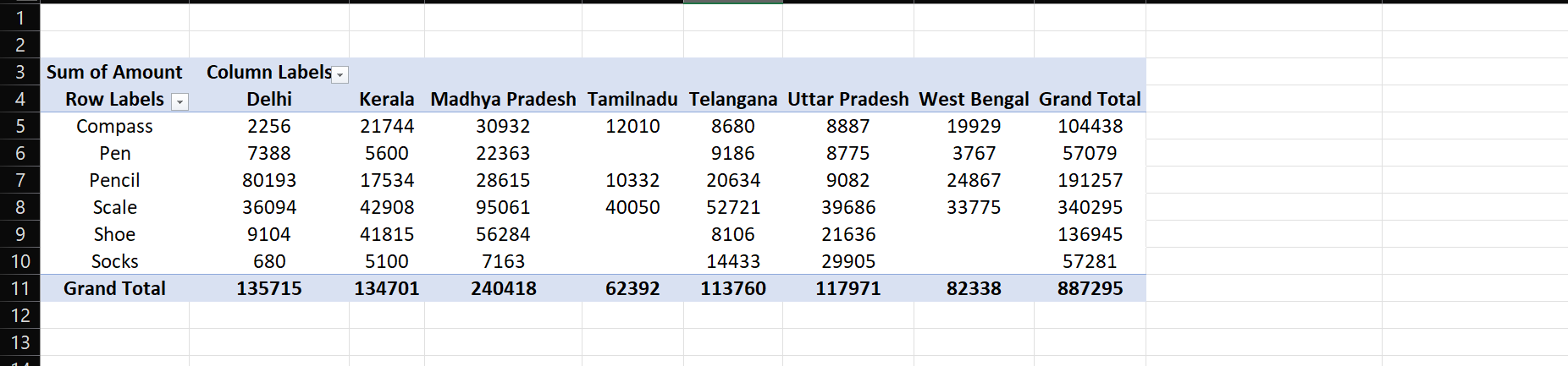

1. Create a chart showing the amount spent for each product in each city.

